COMMUNION SERVICE
SUNDAY 30th MAY at 11.30 am
CONDUCTED BY REV PETER PHILLIPS
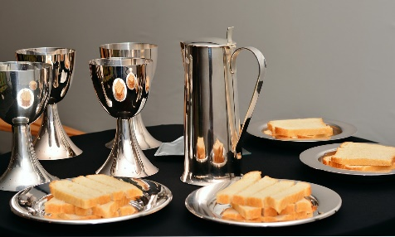
This Service will also be available online from the beginning of the following week
If you would like to take part, please have bread and wine ready
CHURCH FLOWERS
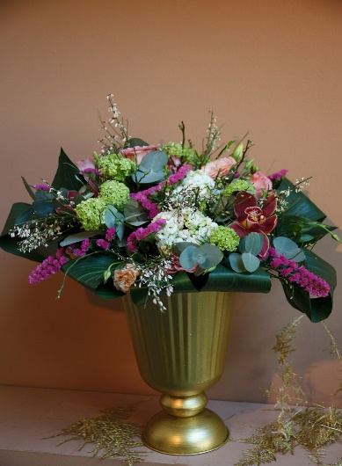 | May  9th Donation  16th Lily Robertson  23rd Rosie Burnett  30th Communion | June  6th Betty Brown  13th Nancy Robbie  20th Margaret Cargill  27th Helen Rosie
If you would be willing to provide the church flowers, please speak to Rosie Burnett, our Flower Convenor

Our thoughts and prayers are with the family and friends of  Gordon Duff, late of Green Beeches, Letham Grange  who died recently. | 